Guideline to enable Internet connection on a VM created using Hyper-V

# Step 1: Open the Hyper-V Manager console

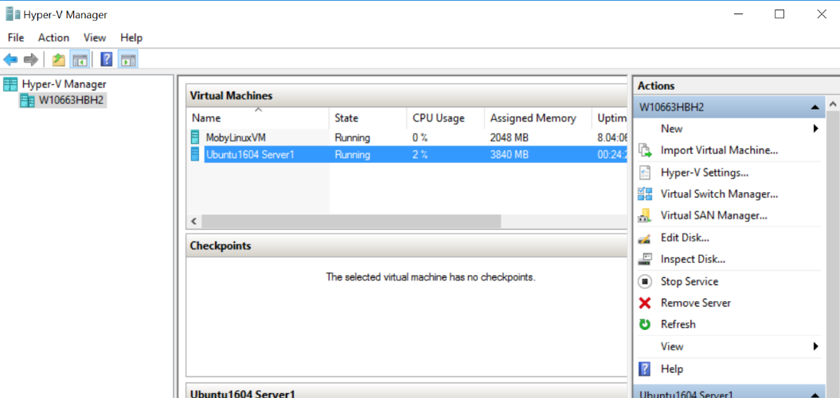

# Step 2: Open Virtual Switch Manager

From the Actions pane, click Virtual Switch Manager.Create a new Virtual Switch Manager (make sure External is selected in virtual switch type list -> hit button “Create Virtual Switch”

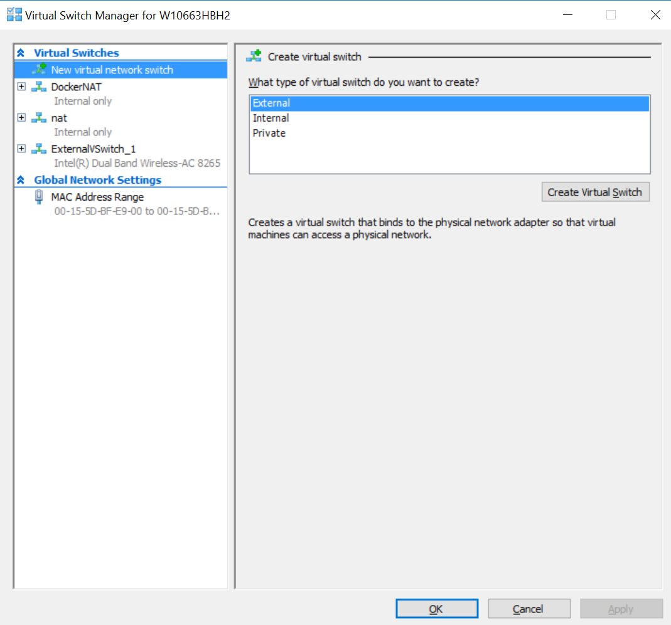

# Step 3: Configure new virtual switch

Give a name to Virtual switch. Also, if it’s wi-fi connectivity, select the wireless adapter in dropdown. For wired connectivity select the Ethernet adapter. In this example for wi-fi connectivity, it looks as following:

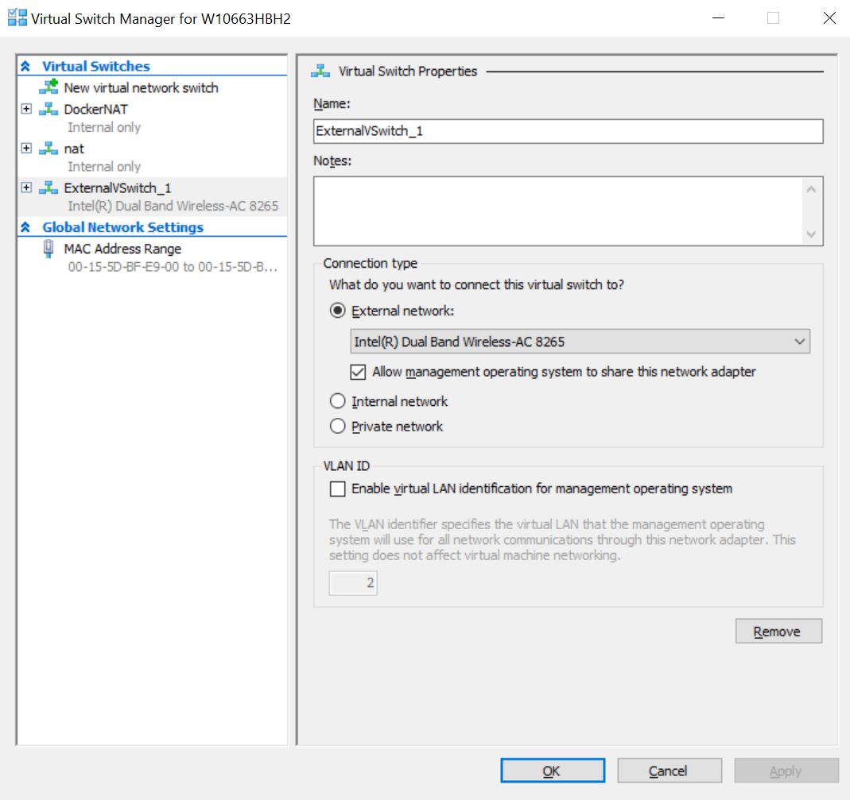

# Step 4: enable the new network adapter in your newly created VM

In this example, I have an Ubuntu 16.04 VM already created. Click on the *Settings* for this VM in Hyper-V manager console

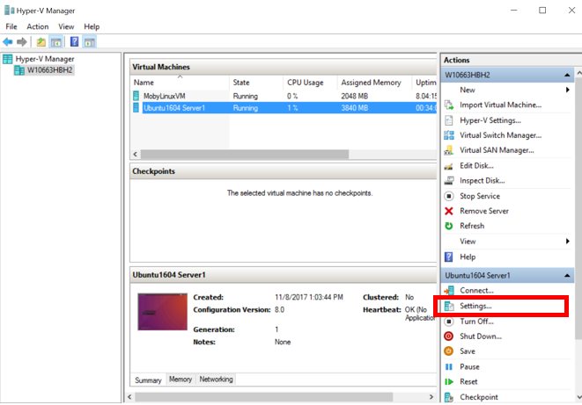

That shall open up new window as following:

See, the highlighted node for *Network adapter*, click on that and in right pane dropdown, select the Virtual Switch you just had created

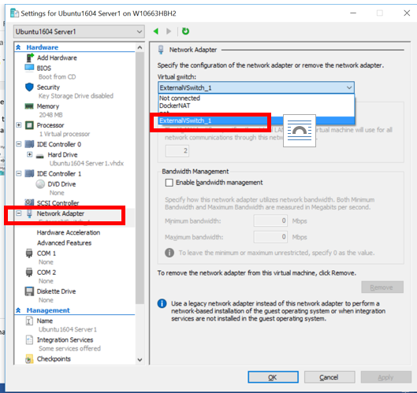

That’s it! Your VM should now be connected to the internet